**IFT 266 Introduction to Network Information Communication Technology**

**Lab 12**

**VLAN – First Look!**  
Co-Authored by Krysha Kaye Jameson  
  
**After you complete each step, put a ‘√’ or ‘x’ in the completed box**

**Objective**

Understand the basic workings of VLAN through the building of 3 isolated networks with 2 computers each and using only 1 switch

1. Setup the following topology in packet tracer.

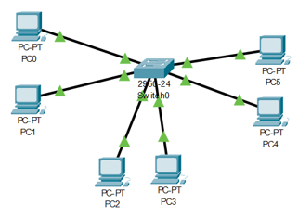



1. Setting up the switch using GUI  
   1. Go to the switch and click the Config tab then go to VLAN Database.

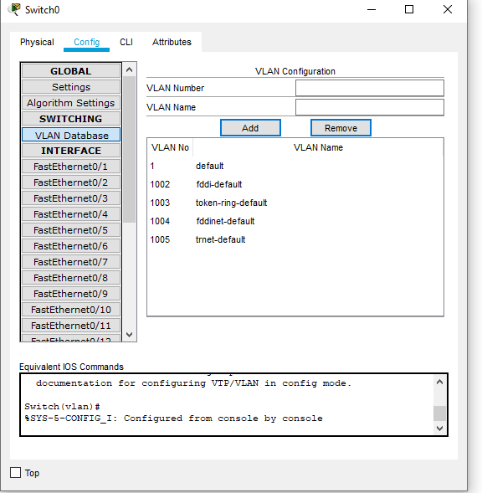



* 1. Click Add and type the VLAN Number and Name as shown below till you have all 3 VLANS

NOTE: Do not use VLAN 1 as that is the default VLAN

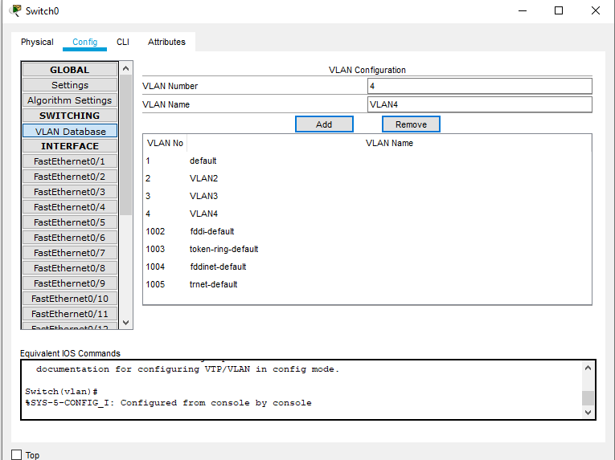



* 1. We will now assign each switch interface to a particular VLAN (the three VLAN’s that we created in the previous step).  
       
     Under interface, click each “FastEthernet#/#”   
       
     Under VLAN, choose each VLAN accordingly with 2 PCs per VLAN. Repeat till all PCs are assigned.

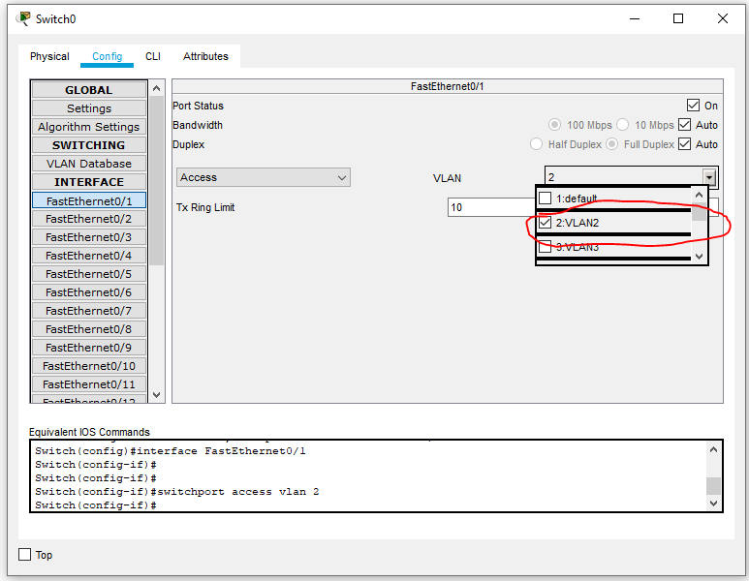



1. Configure the PCs

Set IPs of PC0 and PC1 to be within the same subnet.

PC0 to 192.168.100.1 / Subnet Mask 255.255.255.0

PC1 to 192.168.100.2 / Subnet Mask 255.255.255.0

PC0 should be able to ping PC1 since they are in the same network.

**Attach a screenshot of your successful ping!**

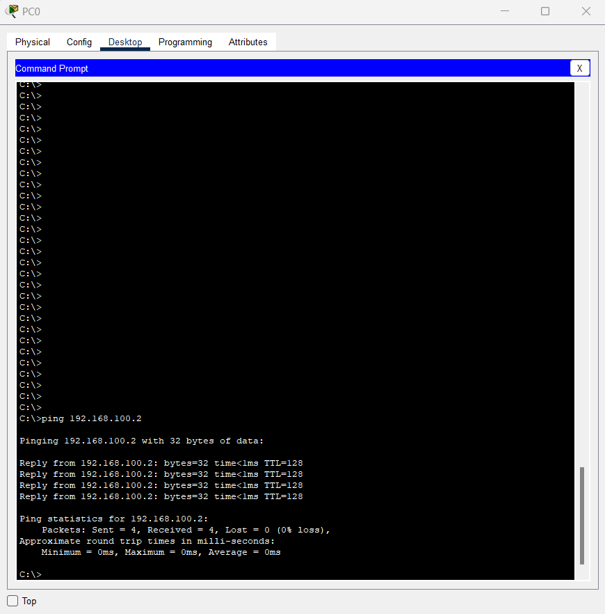

Set PC2 and PC3 to another subnet

PC2 to 192.168.100.3 / Subnet Mask 255.255.255.0

PC3 to 192.168.100.4 / Subnet Mask 255.255.255.0

PC2 should be able to ping PC3 since they are in the same network.

**Attach a screenshot of your successful ping!**

1. Ping PC0 from PC3.   
     
   Did it work? (Yes or No)  
     
   No  
     
     
     
   Why/Why not?

It did not work because it is on a different VLAN. VLAN’s operate like separate networks, so in this scenario and configurations, we essentially created 3 networks within the switch. PC0 is on VLAN 2 and PC3 is on VLAN 3. We would need a router and more configurations to enable frame routing from one VLAN to another.